**ONLINE SHOPPING SYSTEM FOR CS ANTIQUE SHOP**

**Diploma in Software Engineering**

**Final Project Documentation**

**22.1F**



**School of Computing and Engineering**

**National Institute of Business Management**

**Colombo-7**

**Project title**  : Online Shopping System For Cs Antique Shop

**Authors**  : CODSE22.1F-004 D I Dasanayake CODSE22.1F-054 Dilshan

CODSE22.1F-059 S.W.HINGERT

CODSE22.1F-094 E.L.C.L.Silva

**Name of the Program** : Diploma in Software Engineering

**Supervisor** : Mr.Thusitha

**Institution** : School of Computing National institute business management

**Signature** : ……………………………………………………………………….

**Date** : ………………………………………………………………………

**This project is submitted in partial fulfillment of the requirement of the Diploma**

**in Software engineering of the National institute of business management.**

**Declaration**

I certify that this project does not incorporate without acknowledgment, any material previously submitted for a Diploma in any institution, and to the best of our knowledge and belief, it does not contain any material previously published or written by another person or ourselves except where due reference is made in the text. We also hereby consent to our project report, if accepted, to be made available for photocopying and interlibrary loans, and for the title and summary to be made available to outside organizations.

D I Dasanayake ……………………………………………………………………………………………………..

Dilshan ……………………………………………………………………………………………………..

S.W.HINGERT ……………………………………………………………………………………………………..

E.L.C.L.Silva ……………………………………………………………………………………………………..

**Abstract**

CS Antiques is a business that has undertaken the development of a professional e-commerce website to showcase and sell a wide range of antiques and reproduction items. The website aims to provide customers with a convenient platform to browse and purchase unique pieces from the comfort of their own homes. This is particularly valuable in the current digital age, where online shopping has become increasingly popular and preferred by many customers.

Previously, CS Antiques relied on traditional retail methods and manual processes to handle sales and operations. However, with the introduction of the e-commerce website, the company can streamline its processes and effectively manage various tasks associated with the business. This automation not only saves time and reduces physical labor but also enables CS Antiques to reach a larger customer base and increase profitability.

To develop the CS Antiques e-commerce website, a range of professional tools and technologies were utilized. The website was built using the VS code tool, a widely-used code editor. The user interface was meticulously designed using Figma, a powerful design and prototyping tool. For creating a responsive and visually appealing frontend, Bootstrap, a popular framework, was employed. The backend was developed using the Laravel PHP framework, which offers a comprehensive set of tools and libraries for efficient web application development. Furthermore, MySQL was employed as the robust database component, ensuring secure storage and management of product and customer data.

The primary focus of the CS Antiques e-commerce website is to establish a professional online presence, expand the business's reach beyond the local market, and attract a larger customer base. By providing customers with an immersive online shopping experience, CS Antiques aims to showcase its diverse collection of antiques, including pettagams, dressing tables, kanappu, antique beds, antique tables, antique chairs, antique oil lamps, antique brass items, antique cupboards, and ebony items. The website serves as a comprehensive platform where customers can explore, compare prices, and make informed purchasing decisions.

In conclusion, the development of the CS Antiques e-commerce website is a strategic move to adapt to the changing retail landscape and leverage the power of the internet. With the integration of modern technologies and a user-friendly interface, CS Antiques aims to elevate its business and establish itself as a reputable online destination for antique enthusiasts and collectors worldwide.

**Acknowledgement**

We would like to express our heartfelt thanks to the National Institute of Business Management (NIBM) for providing us with this opportunity to work on this project and for supporting us with the physical and mental resources needed to complete it. We are also. grateful to all those who have helped and guided us throughout this project, including us group members, supervisor, course director, and parents, friends, and others who provided. assistance and support.We particularly want to thank Our course Director Mr. Thusitha for supervision and guidance throughout the project, and for offering valuable advice and assistance to help us complete it in a professional and standard manner. We also want to thank all our Diploma level lecturers, for the valuable advice and lessons provided throughout which helped us make this project a success.

We extend our thanks and appreciation to all those who have contributed to the successful completion of this project, including our parents, friends, and others who have supported us directly and indirectly.

Thank you

Contents

Chapter 1: Introduction 6

1.1 Introduction of the Organization 6

1.2 Organization Structure 6

1.3 Current Operations in Organization 7

1.4 Users and Responsibilities in Organization 8

1.5 Problem Definition 9

1.6 Project Objectives 9

1.7 Proposed Solution 10

1.8 Chapter Summary 11

Chapter 2: Methodology 12

2.1 Introduction 12

2.2 Data Collection Methods 12

2.3 Software Process Model 12

2.4 Software Development Tools 13

2.5 Testing Strategies 14

2.6 Implementation Plan 14

2.7 Chapter Summary 15

Chapter 3: Analysis 16

3.1 Introduction 16

3.2 UML Diagrams 17

Chapter 4 Solution design 61

4.1 Introduction 61

4.2 Interface Design 62

4.3 Database Design 86

4.4 Report Design 109

Chapter 5: Conclusion 114

References 116

**CHAPTER 1: Introduction**

1.1 Introduction to CS Antiques Showroom Website

CS Antiques is a prominent showroom specializing in the sale of exquisite antiques and reproduction items. Established as a leading destination for antique enthusiasts and collectors, CS Antiques offers a diverse range of products that includes pettagams, dressing tables, kanappu, antique beds, antique tables, antique chairs, antique oil lamps, antique brass items, antique cupboards, and ebony items.

With a strong commitment to preserving history and offering unique pieces, CS Antiques has gained recognition for its exceptional selection and unwavering dedication to craftsmanship. The showroom provides customers with an opportunity to enhance their living spaces with distinctive and timeless furniture pieces.

Located in a convenient area, CS Antiques showroom serves as a hub for customers seeking exclusive antiques and reproduction items. By showcasing its products in a beautifully curated space, CS Antiques ensures a memorable and enriching shopping experience.

To reach a wider customer base and cater to the evolving needs of the digital age, CS Antiques has embarked on the development of a professional web-based software project. This project aims to create an immersive and user-friendly website that allows customers to explore and purchase their desired antiques and reproduction items.

By leveraging modern technologies, CS Antiques aims to provide customers with a seamless browsing experience, enabling them to discover and compare various products, such as pettagams, kanappu, and varandha chairs. The website will offer detailed product descriptions, high-quality images, and pricing information to assist customers in making informed decisions.

CS Antiques holds customer satisfaction in high regard and strives to deliver exceptional service through its online platform. With a focus on quality, authenticity, and customer-centricity, CS Antiques aims to exceed customer expectations and establish itself as a trusted and reputable online destination for antique enthusiasts worldwide.

In conclusion, the CS Antiques showroom webpage software project represents a significant step in embracing digital transformation and expanding the reach of the showroom beyond its physical location. By creating an engaging and informative online presence, CS Antiques seeks to provide customers with an accessible and immersive shopping experience, showcasing its main products of pettagams, kanappu, and varandha chairs.

**Organizational Structure**

• The organizational structure (OS) of an organization plays a pivotal role in determining how resources are utilized to accomplish business objectives. At CS Antiques Showroom, the company follows a functional organizational structure, which is well-suited for businesses with specialized functions and departments.

• The functional organizational structure at CS Antiques Showroom is designed to establish clear lines of authority, responsibility, and reporting. It ensures that each member of the organization understands their specific role and contributes to the overall success of the showroom.

• In this structure, the showroom is divided into distinct departments based on functions such as sales, procurement, inventory management, customer service, and marketing. Each department is headed by a manager or supervisor responsible for overseeing the activities and performance of the respective department.

• The functional organizational structure facilitates effective coordination and communication between different departments, ensuring smooth workflow and optimal resource allocation. It promotes specialization, as employees within each department possess expertise in their specific areas of responsibility.

• The structure encourages teamwork and collaboration, as employees work together within their respective departments to achieve common goals and objectives. It enables efficient decision-making and problem-solving, as decisions can be made by individuals with the appropriate expertise.

• In summary, the functional organizational structure at CS Antiques Showroom allows for efficient division of labor, clear communication channels, and effective coordination between departments. This structure plays a vital role in enabling the showroom to offer exceptional products and services, maintain customer satisfaction, and uphold its reputation as a premier destination for antique enthusiasts and collectors.

**Current Operations in CS Antiques Showroom**

The operations of CS Antiques Showroom encompass various aspects crucial to its success as a leading provider of antique and reproduction items. The main operations of the organization are as follows:

1. Procurement and Inventory Management:

CS Antiques Showroom carefully selects and procures a diverse range of antique and reproduction items, including pettagams, dressing tables, kanappu, antique beds, antique tables, antique chairs, antique oil lamps, antique brass items, antique cupboards, and ebony items. The showroom maintains an efficient inventory management system to ensure adequate stock levels, proper categorization, and preservation of the items.

2. Showroom Management and Presentation:

CS Antiques Showroom takes pride in creating an aesthetically pleasing and engaging environment for customers. The showroom is meticulously organized to display the items in an attractive manner, allowing customers to explore and appreciate the unique pieces. Showroom management involves regular maintenance, cleanliness, and updating of displays to provide an immersive experience.

3. Sales and Customer Service:

The sales operation at CS Antiques Showroom involves both in-person sales at the physical showroom and online sales through the website. Knowledgeable and customer-oriented staff members assist customers in understanding the history, value, and characteristics of the items. The showroom ensures a seamless purchasing process and delivers excellent customer service to enhance the overall shopping experience.

4. Online Presence and Marketing:

CS Antiques Showroom recognizes the importance of establishing a strong online presence to reach a wider audience. The organization focuses on creating a professional website as a part of its software project, showcasing the collection of antiques and reproduction items. Online marketing strategies, including search engine optimization (SEO), social media marketing, and digital advertising, are employed to increase brand visibility and attract potential customers.

5. Logistics and Delivery:

CS Antiques Showroom manages the logistics and delivery of purchased items to ensure safe and timely transportation. The organization partners with reliable shipping providers to deliver products to customers locally and internationally. Attention to packaging and secure handling is prioritized to preserve the integrity of the items during transportation.

In conclusion, CS Antiques Showroom efficiently operates in the procurement and inventory management, showroom management and presentation, sales and customer service, online presence and marketing, as well as logistics and delivery. These operations collectively contribute to the success of the organization in providing customers with an enriching antique shopping experience.

**1.4 Responsibilities of the administrator in the management of the CS Antiques Showroom website**

The CS Antiques Showroom website is managed by an administrator, who is either the owner of the business or another designated person. The administrator holds various responsibilities in the effective management of the website. These responsibilities include maintaining the product catalog, processing customer orders, managing deliveries, and ensuring smooth operations on the website. Additionally, the administrator is responsible for addressing customer inquiries, reviews, and complaints in a prompt and satisfactory manner. Their role is vital in overseeing the website's functionality and ensuring a seamless experience for visitors and customers.

**1.5 Problem Definition**

• With the increasing reliance on social media marketing due to the challenges posed by the pandemic, CS Antiques Showroom faces difficulties in efficiently handling customer orders and requests solely through social media platforms. Managing a large volume of customer interactions and customizing products manually becomes a challenge.

• The cost and maintenance of a physical showroom are high, prompting the owner to venture into a more cost-effective and convenient online marketplace. This transition would allow for reduced wastage and greater focus on the warehouse and production processes.

• Inefficient manual management of stock levels hampers CS Antiques Showroom's ability to accurately predict and track stock requirements. Manual data and reports are susceptible to loss or misplacement, making it difficult to backtrack raw material usage and effectively manage stock levels.

**1.6 Project Objectives**

The objective of the CS Antiques Showroom website project is to create a visually appealing and user-friendly online platform where customers can explore and purchase a wide range of antique and reproduction items. The website will showcase various products such as pettagams, dressing tables, kanappu, antique beds, antique tables, antique chairs, antique oil lamps, antique brass items, antique cupboards, ebony items, and more. Detailed product descriptions, images, and information will assist customers in making informed decisions.

The website will feature a secure and streamlined checkout process, allowing customers to easily complete their purchases and track their orders. Additionally, customers will have the option to create accounts, saving their billing and shipping information for future convenience. They will also be able to leave reviews and ratings for the products they purchase.

The ultimate goal of the CS Antiques Showroom website is to provide a convenient and satisfying shopping experience for customers, resulting in increased sales and customer satisfaction for the business

**1.7 Proposed Solution**

The proposed solution for CS Antique Showroom is to develop a comprehensive website creation software project specifically designed for antique showrooms. This software will enable CS Antique Showroom to establish a powerful online presence, effectively showcasing their unique collection of antique and reproduction items to a broader customer base. The software project will encompass the following key features:

1. Captivating Website Design: The software will offer a range of visually stunning and customizable website templates tailored to the antique industry. These designs will enhance the overall aesthetics of the CS Antique Showroom website, capturing the essence of vintage charm and elegance.

2. Extensive Product Catalog: The software will provide an intuitive and user-friendly interface for managing and displaying a diverse range of antique and reproduction items offered by CS Antique Showroom. Each product will be accompanied by detailed descriptions, high-resolution images, and relevant information, enabling customers to make informed purchase decisions.

3. Customization Options: The software will incorporate a built-in customization feature, allowing customers to personalize certain items according to their preferences. This feature will enable CS Antique Showroom to cater to the unique needs and desires of their customers, enhancing customer satisfaction and engagement.

4. Streamlined Order Processing: The software project will include a robust order management system that seamlessly processes customer orders, generates invoices, and tracks delivery status. This efficient workflow will ensure timely order fulfillment, minimizing errors and improving customer experience.

5. Inventory Management: The software will incorporate a comprehensive inventory management module that enables CS Antique Showroom to effectively track and manage stock levels. The system will provide real-time insights into available stock, automatic restocking notifications, and generate reports to facilitate informed decision-making and reduce manual errors.

6. Customer Engagement and Feedback: The software will feature interactive elements such as customer reviews, ratings, and a personalized customer account system. These features will encourage customer engagement, provide valuable feedback, and foster a sense of community within the CS Antique Showroom website.

By implementing this software project, CS Antique Showroom will experience numerous benefits, including increased convenience for customers, streamlined operations, access to valuable analytics and customer insights, improved responsiveness to buyer demands, and the potential for a wider reach of their customer base. The website creation software project will empower CS Antique Showroom to establish a strong online presence and effectively showcase their exquisite collection of antique and reproduction items, driving business growth and customer satisfaction in the competitive antique market.

**1.8 Chapter Summary**

The purpose of the CS Antique Showroom website creation software project is to develop a comprehensive solution that enables the establishment of a captivating online platform for customers to explore and purchase a wide range of antique and reproduction items. The project aims to address the challenges faced by CS Antique Showroom, including the need for a cost-effective and convenient online marketplace, efficient stock management, and improved customer engagement.

The proposed solution involves the development of a website creation software specifically tailored for antique showrooms. This software will incorporate captivating website designs that capture the vintage charm of antique items. It will provide extensive product catalog management, allowing detailed descriptions, high-quality images, and customization options to cater to customers' unique preferences.

The software project will streamline the order processing workflow, ensuring efficient order management, invoicing, and delivery tracking. Additionally, it will incorporate a robust inventory management system to track and manage stock levels effectively, providing real-time insights and automating restocking notifications.

By implementing the software project, CS Antique Showroom aims to achieve numerous benefits, including increased convenience for customers, improved operational efficiency, access to valuable analytics and customer feedback, enhanced responsiveness to buyer demands, and the potential to expand their customer base.

In summary, the CS Antique Showroom website creation software project will empower the business to establish a strong online presence, showcase their exquisite collection of antique and reproduction items, and streamline their operations. This will result in improved customer satisfaction, increased sales, and growth opportunities in the competitive antique market.

**CHAPTER 2: Methodology**

2.1 Introduction

Before embarking on the development of the CS Antique Showroom website creation software project, thorough planning and preparation were conducted. This involved identifying the challenges faced by CS Antique Showroom in their current sales and marketing operations and defining the objectives of the project. Extensive research was carried out to understand the needs and preferences of the target audience, as well as to assess the capabilities and limitations of the project team.

The planning and development of the CS Antique Showroom website creation software project required careful consideration of the target audience's requirements, the project team's capabilities, and the selection of appropriate tools and technologies.

In this chapter, we will delve into the planning process, methodologies, and software development approaches employed in the CS Antique Showroom website creation software project.

2.2 Data Collection Method

To build a successful CS Antique Showroom e-commerce platform, various methods were utilized to collect data from customers and other stakeholders. These methods included:

Surveys: Online surveys and email questionnaires were administered to gather information from customers regarding their preferences and behaviors when shopping for antique items. The data collected from these surveys was instrumental in shaping the design, features, and user experience of the website, as well as identifying potential areas for improvement.

Interviews: In-depth interviews were conducted with key stakeholders, including the owner of CS Antique Showroom and members of the marketing and sales teams. These interviews provided valuable insights and ideas that guided the direction of the project, ensuring that the website aligned with the business's objectives and catered to the needs of its customers.

Focus groups: Small group discussions, known as focus groups, were organized with a select number of customers. These sessions allowed for in-depth conversations about customers' experiences with CS Antique Showroom's current sales and marketing operations, as well as their expectations for the e-commerce platform. The insights gained from these focus groups helped identify key features and functionalities that should be incorporated into the website.

Online reviews and ratings: Analysis of online reviews and ratings of CS Antique Showroom's products and services provided valuable insights into customer experiences and preferences. This data played a crucial role in informing the design, content, and user feedback mechanisms of the website, as well as identifying areas that required improvement.

Customer service inquiries: Customer service inquiries were thoroughly examined to gather data on common issues or areas for enhancement within CS Antique Showroom's current sales and marketing operations. This data informed the design and functionality of the e-commerce platform, ensuring that it addressed the specific needs and concerns of customers.

By employing these data collection methods, the CS Antique Showroom website creation software project obtained crucial insights from customers and stakeholders, enabling the development of a tailored and customer-centric e-commerce platform that caters to the unique requirements of the antique showroom industry.

**2.3 Software Process Model**

The Agile software development model, with its iterative and incremental approach, is well-suited for the CS Antique Showroom website creation software project. This model emphasizes flexibility and adaptability to accommodate changing requirements and market dynamics. The Agile model divides the project into small, manageable cycles known as "sprints," where each sprint focuses on specific tasks or features. At the end of each sprint, the team reviews the progress and adjusts the plan accordingly.

The Agile model aligns with the values and principles that guide the CS Antique Showroom website creation software project, including:

- Individuals and interactions: The Agile model emphasizes the importance of effective collaboration and empowering the development team. The team members should be encouraged to make decisions and work together to achieve project objectives.

- Working software: Agile prioritizes the delivery of functional software to customers in a timely manner. The focus is on providing a working product that meets the requirements and can be improved upon iteratively, rather than striving for perfection from the outset.

- Customer collaboration: Agile encourages close collaboration with customers throughout the development process. The team should actively involve customers in gathering feedback, understanding their needs, and incorporating their input into the project. This ensures that the resulting website meets the expectations and goals of CS Antique Showroom.

- Responding to change: Agile acknowledges that requirements and priorities can evolve over time. The team should be prepared to adapt and respond to these changes promptly, adjusting the project plan and incorporating new insights as necessary.

By adopting the Agile software development model, the CS Antique Showroom website creation software project can embrace flexibility, collaboration, and responsiveness to create a high-quality and customer-focused e-commerce platform that aligns with the evolving needs of the antique showroom industry.

**Benefits of Agile Development**

There are several benefits to using the Agile development model for the CS Antique Showroom website creation software project:

1. Faster delivery: The Agile model's iterative approach allows for quicker delivery of working software. This means that customers can start using and providing feedback on the website earlier in the development process, leading to faster improvements and a shorter time to market.

2. Increased flexibility: Agile is designed to accommodate changing requirements and priorities. This flexibility allows the development team to respond to feedback, incorporate new features, and adapt the website to evolving market conditions or customer needs.

3. Improved collaboration: Agile promotes collaboration and communication between the development team, stakeholders, and customers. Regular meetings, feedback sessions, and a collaborative work environment foster better understanding, alignment, and more effective problem-solving throughout the project.

4. Enhanced quality: The Agile model emphasizes continuous testing and evaluation. By integrating testing and quality assurance into each iteration, potential issues can be identified and addressed early on, resulting in a higher-quality website.

5. Greater customer satisfaction: By involving customers throughout the development process, the Agile model ensures that their needs and preferences are considered and incorporated into the website. This leads to a higher level of customer satisfaction and a website that better meets their expectations.

6. Efficient resource utilization: Agile allows for prioritization and optimization of resources based on customer feedback and changing requirements. This enables the development team to focus on high-value features and deliver a product that maximizes customer value within the project's time and resource constraints.

Overall, adopting the Agile development model for the CS Antique Showroom website creation software project can lead to faster delivery, increased flexibility, improved collaboration, enhanced quality, greater customer satisfaction, and efficient resource utilization. These benefits contribute to the successful creation of a high-quality and customer-centric website for the antique showroom.

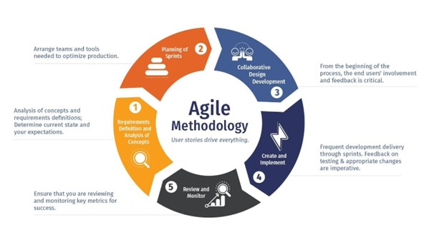

**2.4 Software Development Tools**

The following tools were utilized for the development of the project:

• **Figma**

Figma is a cloud-based design and prototyping tool that

allows teams to collaborate on design projects in real

time. We used Figma to create wireframes and mockups

of the Cushion House platform, which helped us

visualize and plan the layout and functionality of the

site.

 **• Html, CSS, Java Script**

These are all programming languages that are used to

build the frontend of a website. HTML (Hyper Text

Markup Language) is used to structure the content of a

webpage, CSS (Cascading Style Sheets) is used to style

the content, and JavaScript is used to add interactivity and

dynamic elements to the page. We used these languages to build the user interface of the Cushion House platform.

**• Laravel**

Laravel is a PHP web application framework used for web

development. It was used to build the backend of the

Cushion House platform, including handling routing,

authentication, and database management

17

 • **Bootstrap**

Bootstrap is a frontend framework that provides a set of

pre-designed elements and styles that can be easily

customized and used to build responsive, mobile-first

websites. We used Bootstrap to create a consistent and

responsive design for the Cushion House platform.

** • jQuery**

jQuery is a JavaScript library that simplifies the process of

adding interactive elements and effects to a webpage. We

used jQuery to add dynamic features to the Cushion House

platform, such as sliders and modals.

** • MySQL**

MySQL is a popular database management system that

was used to store and manage the data for the Cushion

House platform. It was used to store information about

products, orders, customers, and more.

These tools were all used to build the Cushion House ecommerce platform, and they allowed

us to create a professional and functional online store.

On-premise System:

This segment of the solution is deployed within the premises of the retail store and caters to the needs of staff engaged in retail activities, including store managers and cashiers. Specific requirements for each role are outlined in the Use Case diagram. The Master Control System (MCS) will operate on a central computer accessible to store managers. Smaller versions of the MCS related to the Point-of-Sales (POS) subsystem will also run on computers stationed at customer checkout locations, where cashiers will interact with them. The system will be developed using Java.

Web Platform:

While the web platform offers limited functionality compared to the On-premise system, it must deliver a stable, satisfactory service to act as a compelling feature. To achieve this, the backend will be developed using PHP. This backend will interface with the previously mentioned database for tasks such as item selection and order placement. HTML and CSS will be used on the front end to create user interfaces, as detailed in Chapter 4.2 "Interface Design". JavaScript will handle client-side interactions.

Delivery System:

The delivery system, a mobile application for the delivery staff, should be lightweight to ensure it can be easily installed on their personal phones without consuming excessive storage. Kotlin will be employed to implement this system due to its interoperability with Java, enhancing the development experience, given that the On-premise system is designed with Java.

**2.5 Testing Strategies**

Software testing strategies are essential for ensuring the quality and functionality of a software product, including the CS Antique Showroom website creation software project. Here are some testing strategies that can be employed for this project:

1. Static testing: Static testing involves reviewing and examining the code and design of the software without executing it. This can include activities such as code review, inspection, and verification. Static testing ensures that the codebase of the CS Antique Showroom website is well-written, adheres to coding standards, and is free of defects.

2. Structural testing: Structural testing focuses on testing the internal structure and behavior of the software, including individual units, components, and their interactions. This can involve unit testing, integration testing, and system testing. By testing the different components of the CS Antique Showroom website and how they interact with each other, structural testing ensures the overall integrity and functionality of the software.

3. System testing: System testing involves testing the entire system as a whole, including all components and their interactions. It verifies that the CS Antique Showroom website functions correctly and meets the specified requirements. System testing includes testing all features, functionality, and user interactions to ensure a seamless and integrated experience.

4. Behavioral testing: Behavioral testing focuses on testing the software's behavior under different conditions, including usability testing, performance testing, and acceptance testing. Usability testing ensures that the CS Antique Showroom website is user-friendly and intuitive for visitors. Performance testing verifies that the website can handle a large volume of traffic and transactions efficiently. Acceptance testing ensures that the website meets the expectations and requirements of the stakeholders.

By employing these testing strategies, the CS Antique Showroom website creation software project can ensure a high-quality, reliable, and user-friendly website that meets the needs and goals of the antique showroom.

**2.6 Implementation Plan**

An implementation plan is crucial for successfully implementing the CS Antique Showroom website creation software project. It outlines the necessary steps and resources needed to ensure a smooth and efficient implementation process. The plan helps organize the project, assign responsibilities, and minimize risks and errors. It also ensures that the final product aligns with the project's goals and objectives.

For the implementation of the CS Antique Showroom website creation software project, the following steps can be included in the plan:

1. Requirement Analysis: Identify and document the specific requirements of the CS Antique Showroom website creation software. This includes understanding the needs of the antique showroom, its customers, and the functionality required from the website creation software.

2. Resource Planning: Determine the required resources for the project, including the development team, software tools, hardware infrastructure, and any external support or services needed.

3. Development and Testing: Utilize an Agile development approach to iteratively develop the CS Antique Showroom website creation software. This involves dividing the project into sprints and delivering working software incrementally. Conduct thorough testing during each sprint to ensure the quality and functionality of the software.

4. Parallel Implementation: Adopt a parallel implementation approach, where the CS Antique Showroom website creation software is implemented alongside the existing processes and systems. This allows for a gradual transition, minimizes disruptions, and enables continuous testing and refinement.

5. Training and User Adoption: Provide training sessions to the antique showroom staff and stakeholders involved in using the website creation software. Ensure that they understand the functionalities and features of the software and can effectively utilize it to create and manage websites for the showroom.

6. Deployment and Monitoring: Deploy the CS Antique Showroom website creation software in a production environment. Monitor its performance, collect user feedback, and address any issues or enhancements that arise during the initial period of use.

7. Documentation and Support: Create comprehensive documentation for the CS Antique Showroom website creation software, including user guides and technical manuals. Establish a support system to address any queries or technical issues that users may encounter.

**2.7 Chapter Summary**

In summary, the CS Antique Showroom website creation software project involved data collection from customers and stakeholders using surveys, interviews, focus groups, online reviews, and customer service inquiries. The Agile software development model was employed, and various tools such as Figma, HTML, CSS, JavaScript, Laravel, and MySQL were used in the development process. The implementation plan included steps such as requirement analysis, resource planning, development and testing, parallel implementation, training and user adoption, deployment and monitoring, and documentation and support. These efforts ensured that the CS Antique Showroom website creation software met the needs and preferences of the antique showroom and its customers.

# Chapter 3: Analysis

3.1 Introduction

To aid in the process of development, the design of the system is expressed in Unified Modeling Language (UML) and other diagrammatic representations such as the Entity-Relationship (ER) Diagram. This chapter aims to comprehensively provide the set of diagrams that were designed by the team to aid in the development stage of the project.

The diagrams depicted are as follows:

* Use-case diagram of the system.
* Class diagram.
* Sequence diagrams.
* ER diagram.

The use case diagram lays out the actions performed by each individual stakeholder directly involved with the system. These will be termed actors. These actors may interact with the system to obtain some form of result. Even though the entire solution is an ecosystem of three different applications, this can be represented within one use case diagram as it acts as a whole integral entity.

The class diagrams define the classes that are derived into objects during the development phase. All attributes that are private are allowed to have getters and setters if and only if necessary. This is at the discretion of the developer. This boilerplate data is removed from being represented in the class diagram in order to avoid unnecessary bloating.

The sequences define the intricacies behind the major use cases described in the class diagram. The level of abstraction depicted varies with the complexity of the action.

The ER diagram describes the entities that are manifested as tables in the database, and the relationships between them, which manifest as tables and foreign keys in themselves. Note that all three applications would be performing CRUD operations on the database. The enforcement of some systems to deal with race conditions and such would be up to the development and is not considered in the design diagrams.

3.2 UML Diagrams

Use Case Diagram

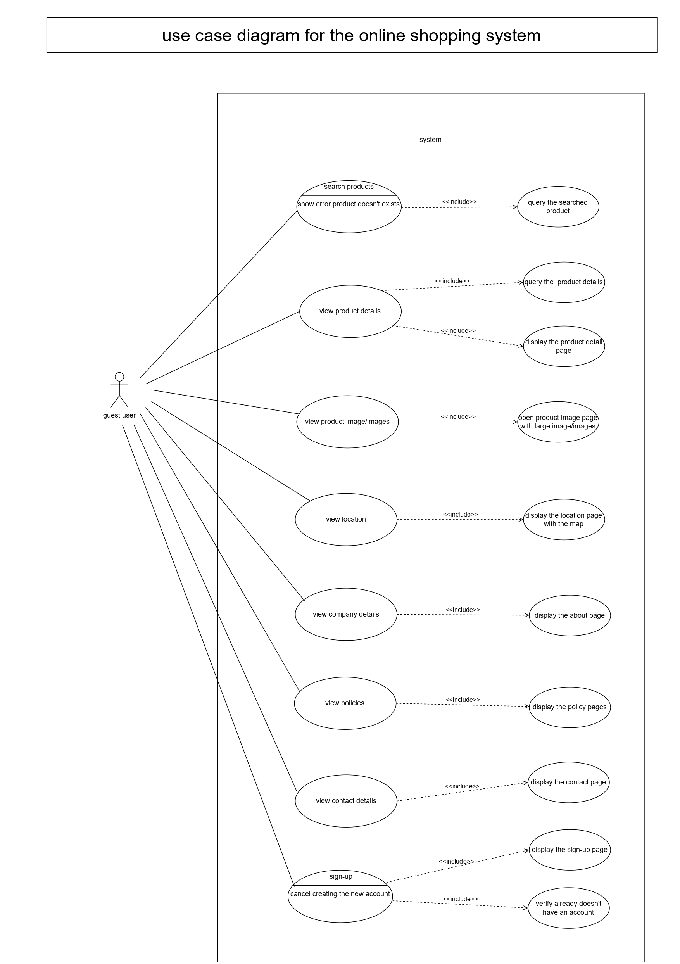

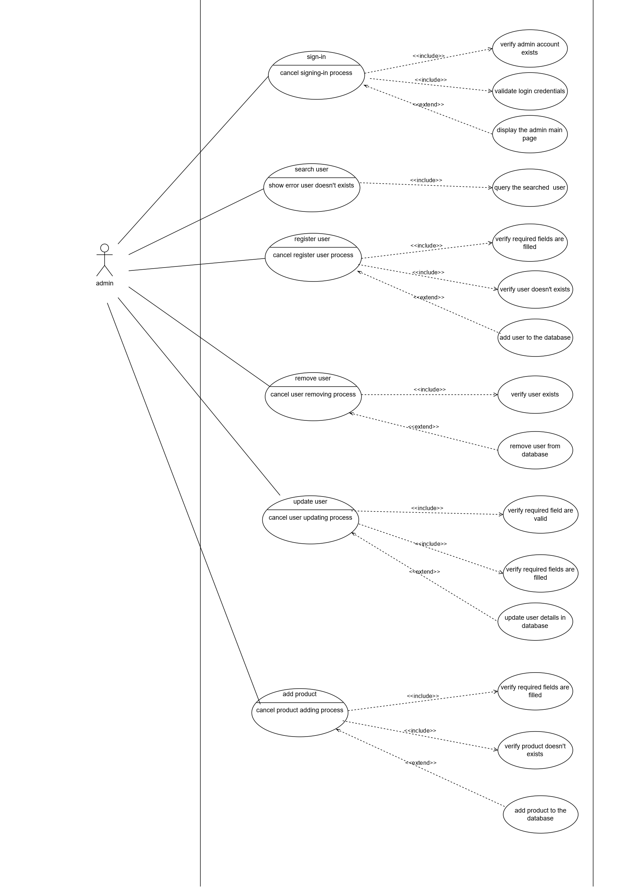

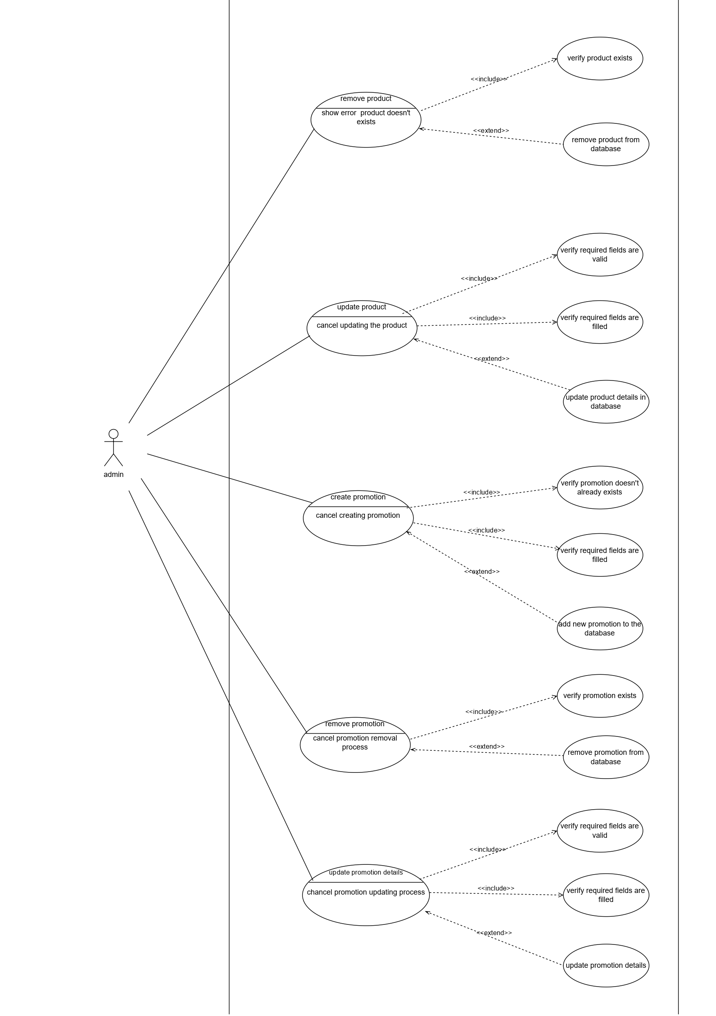

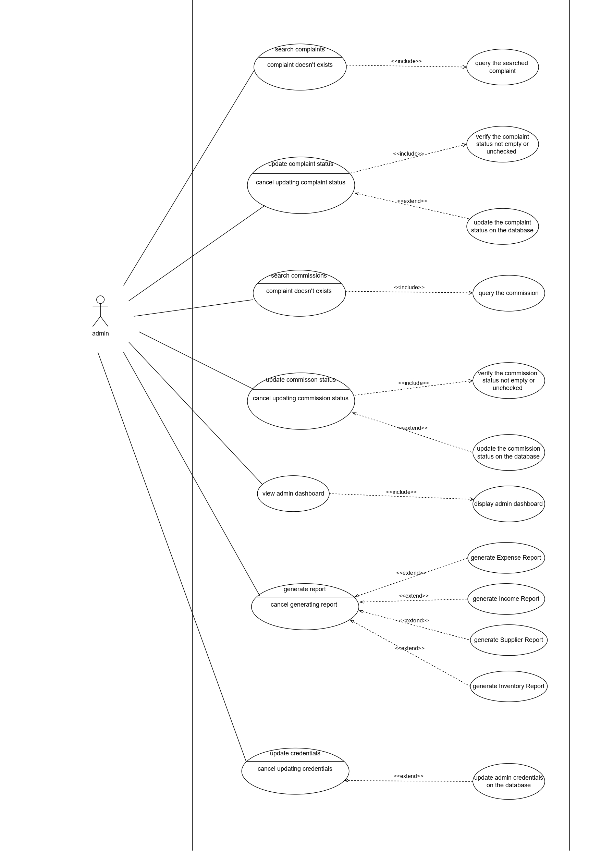

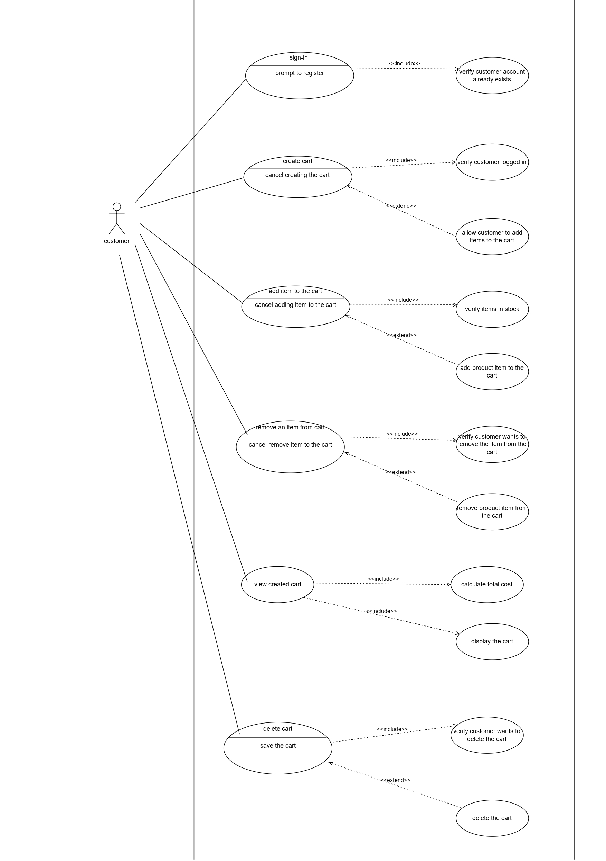



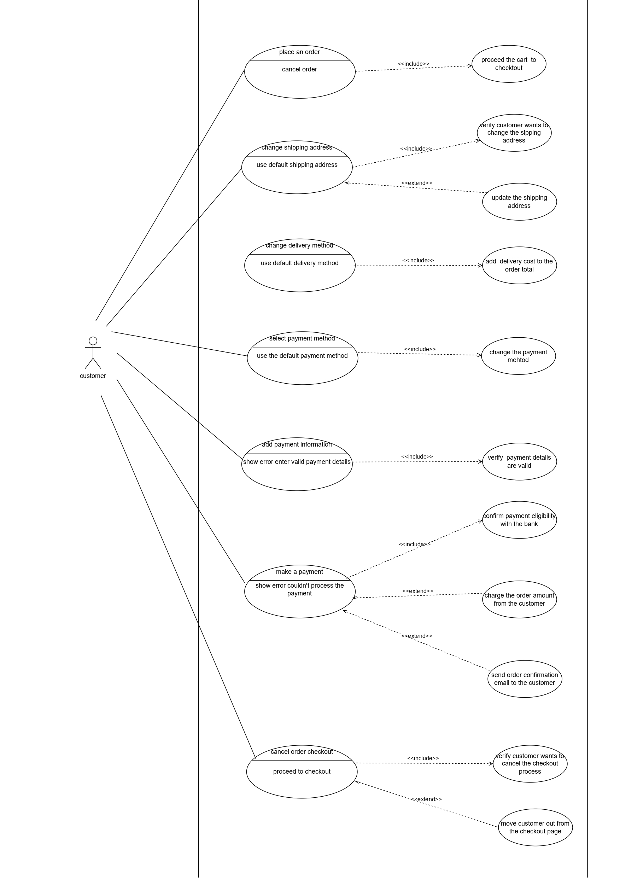

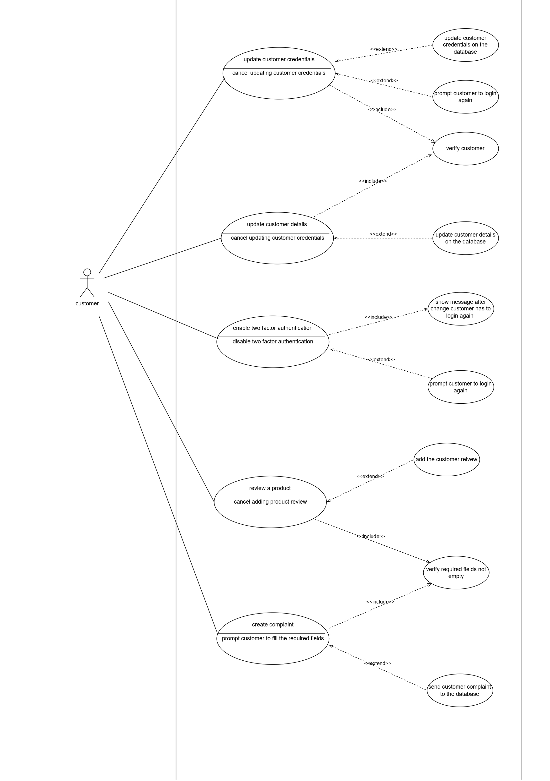

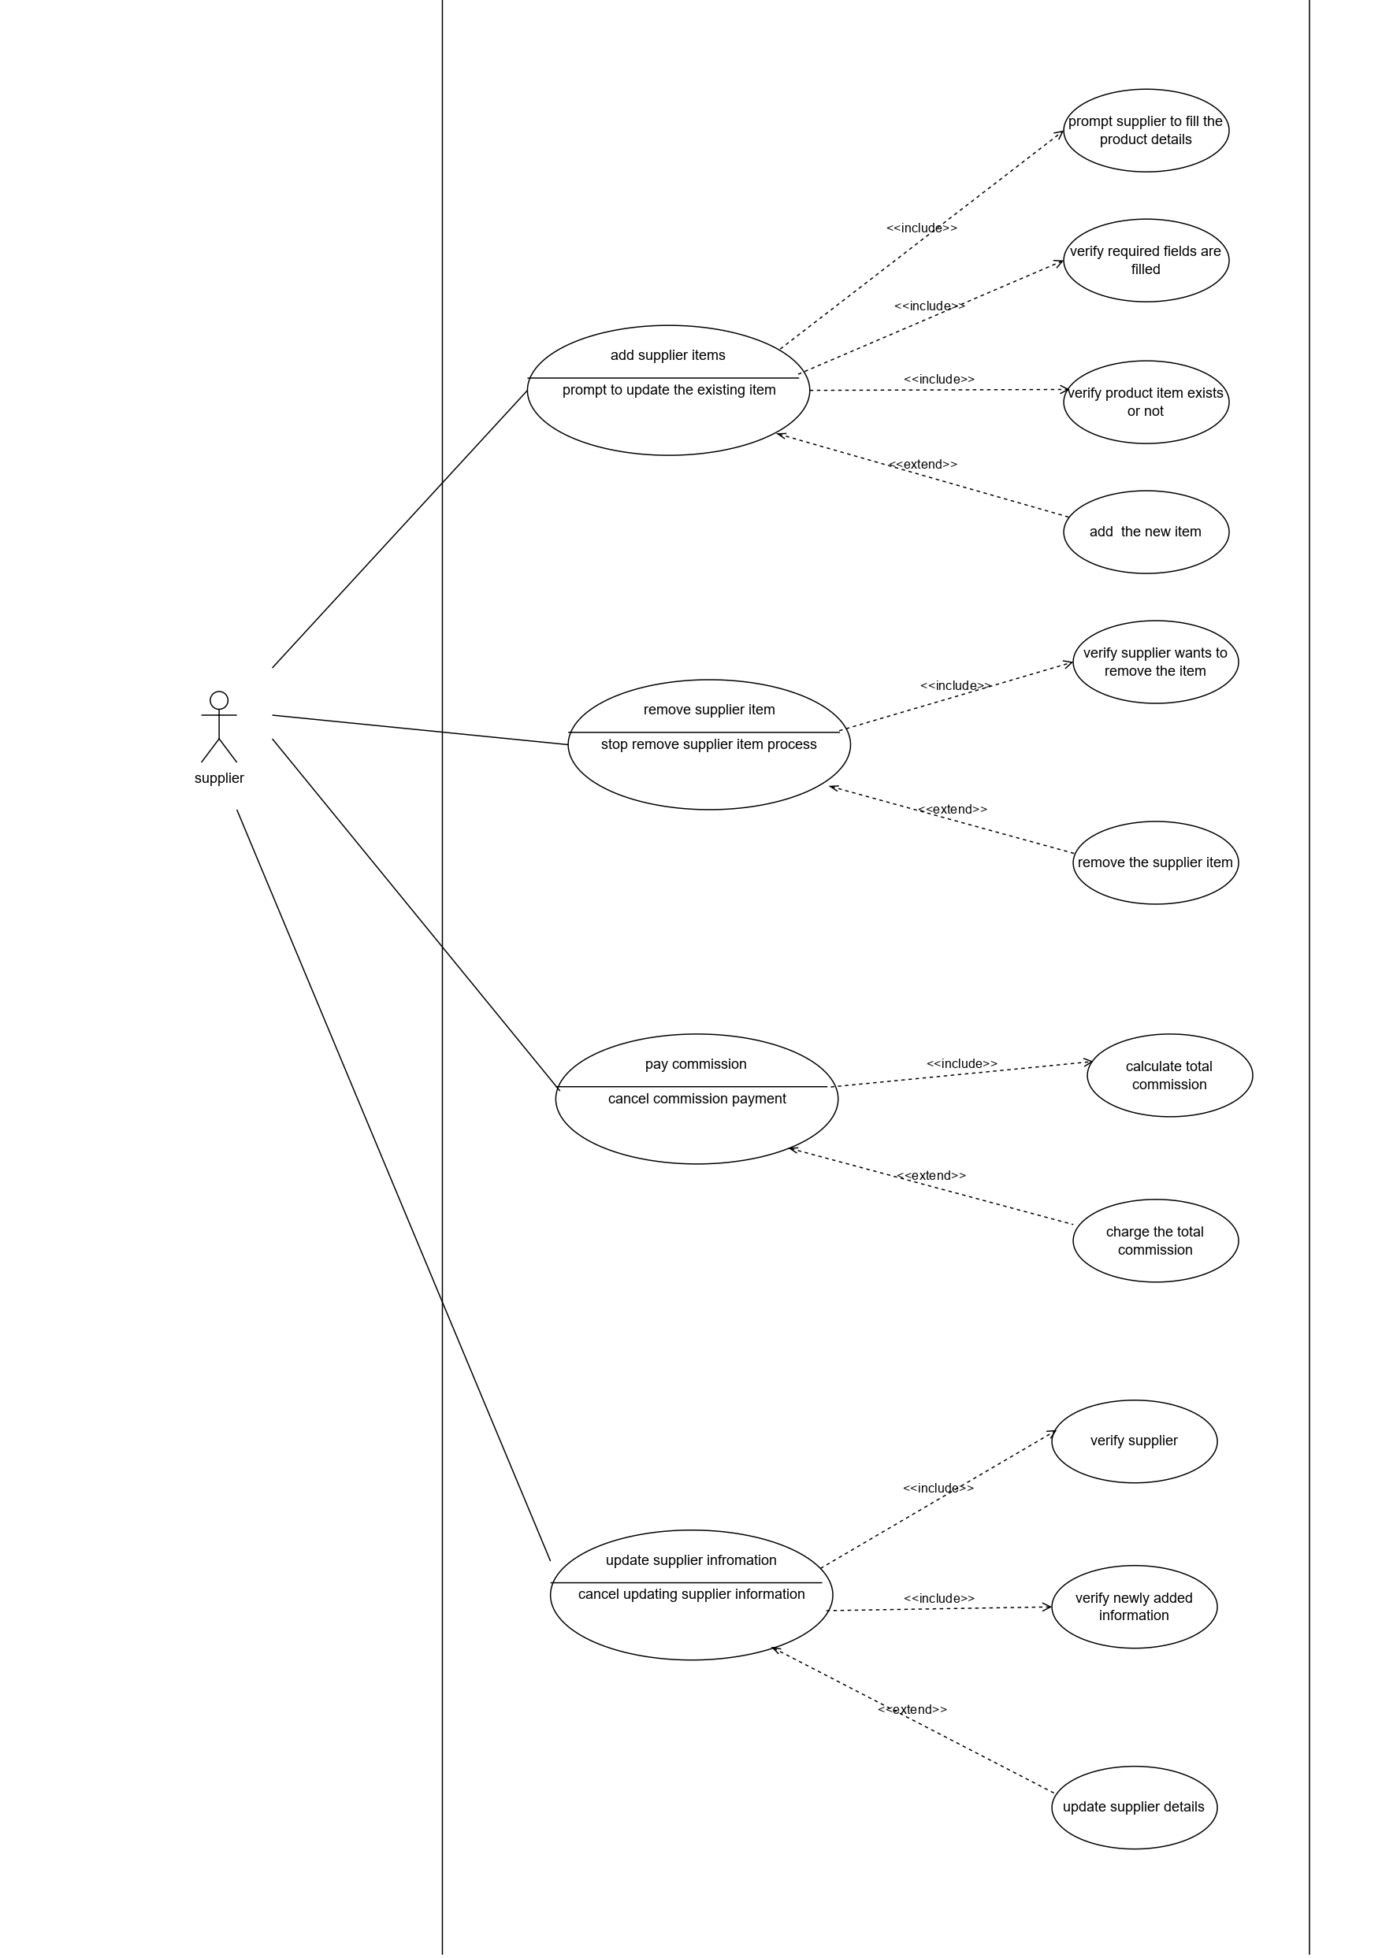

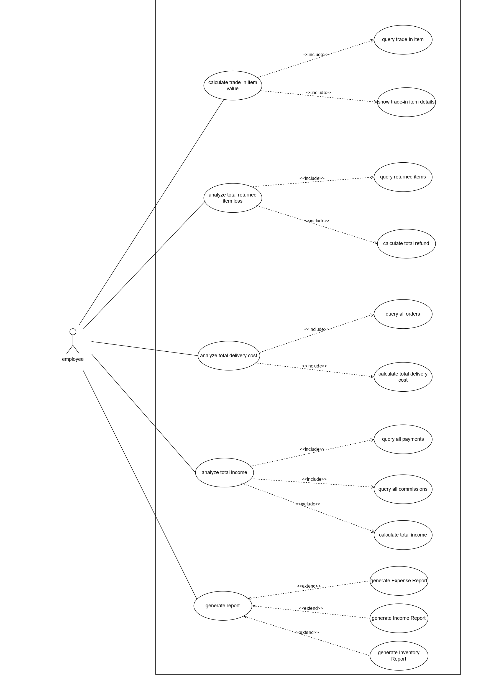

Class Diagram

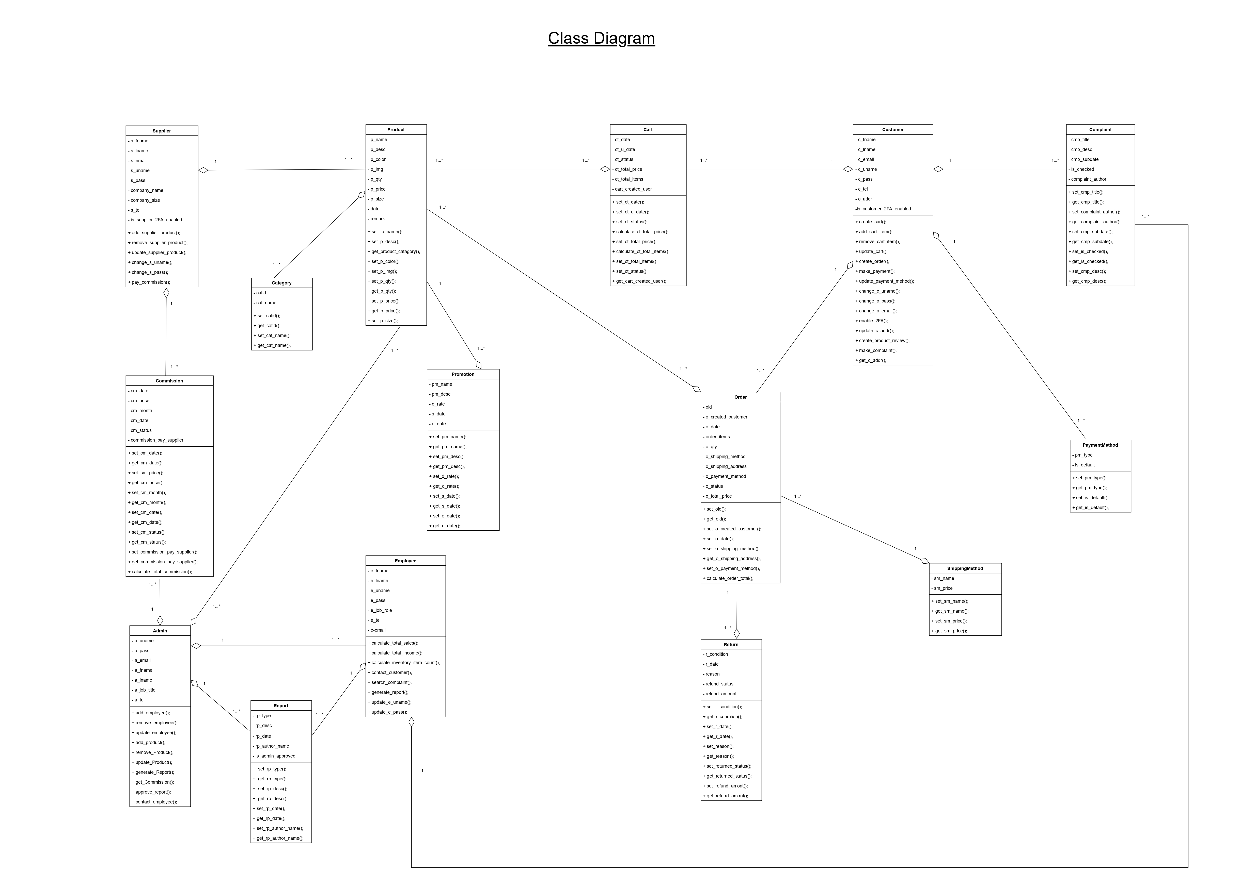

Sequence Diagrams

3.3 ER Diagram

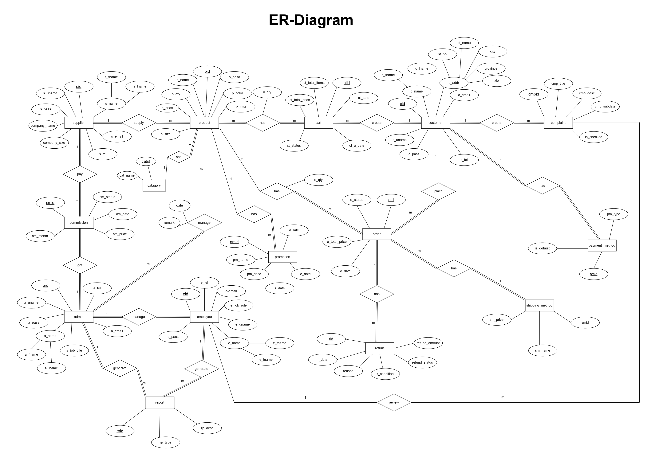

**3.4 Software Architecture**

• Software architecture refers to the organization of a system, including its components, their interactions, the operating environment, and the design principles used. For the CS Antique Showroom website creation software project, the team decided to utilize the MVC (Model-View-Controller) architecture.

• The MVC architecture separates the internal representation of information from the user interface. The Model component handles data-related logic, the View component manages the user interface, and the Controller acts as an intermediary between the Model and View. It processes business logic, manipulates data using the Model, and interacts with the Views to present the final output. Adopting the MVC architecture enables a more organized and efficient system.

**3.5 Chapter Summary**

• The analysis phase of the CS Antique Showroom website creation software project involved gathering and examining information to understand the business needs, goals, and constraints.

• Stakeholder interviews, documentation review, and prototyping were utilized during the analysis phase to visualize the proposed solution.

• Thorough analysis of requirements and constraints ensured the feasibility and alignment of the final solution with stakeholder needs.

• Documentation and communication of the analysis results were done through various diagrams and descriptions, including use case diagrams, class diagrams, UML ER diagrams, and software architecture descriptions. These artifacts provided a clear understanding of the proposed solution and its implementation.

# Chapter 4 Solution design

4.1 Introduction

The following chapter details the specifics of the solution.

Its sections will dive into the design of the UIs, with snapshots of the proposed UI designs laid out. Afterward, the design of the database will be discussed. The structure of the database was laid out in Chapter 3. This section will expand on the entities discussed by providing the table designs associated with them and those which arise because of their relationship with other entities.

Lastly, the analytic functionality of the system would be briefly touched upon by providing templates containing the structure of the proposed reports. The reports are digitally produced summaries of various aspects of the retail business. The system provides five different comprehensive reports, from which the store manager may make educated business decisions that will aid in improving Mallika Store’s outlook by providing its customers with a better shopping experience.

The reports chosen are as follows:

* Monthly Feedback Report
* Weekly Proportion of Sales by Category Report
* Outstanding Credit Report
* Monthly Inventory Report
* Monthly Sales and Purchases Report

# Chapter 4 Solution design

4.1 Introduction

The following chapter details the specifics of the solution.

Its sections will dive into the design of the UIs, with snapshots of the proposed UI designs laid out. Afterward, the design of the database will be discussed. The structure of the database was laid out in Chapter 3. This section will expand on the entities discussed by providing the table designs associated with them and those which arise because of their relationship with other entities.

Lastly, the analytic functionality of the system would be briefly touched upon by providing templates containing the structure of the proposed reports. The reports are digitally produced summaries of various aspects of the retail business. The system provides five different comprehensive reports, from which the store manager may make educated business decisions that will aid in improving Mallika Store’s outlook by providing its customers with a better shopping experience.

The reports chosen are as follows:

* Monthly Feedback Report
* Weekly Proportion of Sales by Category Report
* Outstanding Credit Report
* Monthly Inventory Report
* Monthly Sales and Purchases Report

4.2 Interface Design

4.3 Database Design

**File Design**

**Admin Table**

Primary Key: aid

|  |  |  |  |
| --- | --- | --- | --- |
| Field Name | Data Type | Data Size | Description |
| aid | Number | 5 | Admin id |
| a_uname | Text | 10 | Admin user name |
| a_pass | Text | 10 | Admin password |
| a_fname | Text | 15 | Admin first name |
| a_lname | Text | 20 | Admin last name |
| a_job_title | text | 10 | Admin job title |
| a_email | Text | 20 | Admin email |
| a_tel | Text | 10 | Admin telephone number |
| Record Size |  | 100 |  |

**Admin-Product Table**

Primary key: aid,pid

Foreign key: aid,pid

|  |  |  |  |
| --- | --- | --- | --- |
| Field Name | Data Type | Data Size | Description |
| aid | Number | 5 | Admin id |
| pid | Number | 5 | Product id |
| date | Text | 5 | Date managed |
| remark | Text | 10 | Remark detail |
| Record Size |  | 25 |  |

**Product Table**

Primary key: pid

Foreign Key: sid

|  |  |  |  |
| --- | --- | --- | --- |
| Field Name | Data Type | Data Size | Description |
| pid | Number | 5 | Product id |
| sid | Number | 5 | Supplier id |
| p_name | Text | 15 | Product name |
| p_desc | Text | 150 | Product description |
| p_qty | Number | 5 | Product quantity |
| p_catagory | Text | 15 | Product catagory |
| p_size | Text | 10 | Product size |
| p_color | Text | 10 | Product color |
| p_img | Text | 50 | Product image |
| Record Size |  | 265 |  |

**Product-Order Table**

Primary key: oid ,pid

Foreign key: oid ,pid

|  |  |  |  |
| --- | --- | --- | --- |
| Field Name | Data Type | Data Size | Description |
| oid | Number | 5 | Order id |
| pid | Number | 5 | Product id |
| o_qty | Number | 2 | Order product quantity |
| Record Size |  | 12 |  |

**Order Table**

Primary key: oid

Foreign key: smid, cid

|  |  |  |  |
| --- | --- | --- | --- |
| Field Name | Data Type | Data Size | Description |
| oid | Number | 5 | Order id |
| cid | Number | 5 | Customer id |
| smid | Number | 5 | Shipping method id |
| o_status | Text | 15 | Order status |
| o_total_price | Number | 6 | Order total price |
| o_date | Date |  | Order date |
| Record Size |  | 36 |  |

**Supplier table**

Primary kay: sid

Foreign key:

|  |  |  |  |
| --- | --- | --- | --- |
| Field Name | Data Type | Data Size | Description |
| sid | Number | 5 | Supplier id |
| s_uname | Text | 10 | Supplier user name |
| s_pass | Text | 10 | Supplier password |
| s_email | Text | 20 | Supplier email |
| s_tel | Text | 10 | Supplier telephone number |
| s_fname | Text | 20 | Supplier first name |
| s_lname | Text | 20 | Supplier last name |
| company_name | Text | 30 | Company name |
| company_size | Text | 20 | Company size |
| Record size |  | 145 |  |

**Commission Table**

Primary key: cmid

Foreign key: aid, sid

|  |  |  |  |
| --- | --- | --- | --- |
| Field Name | Data Type | Data Size | Description |
| cmid | Number | 5 | Commission id |
| aid | Number | 5 | Admin id |
| sid | Number | 5 | Supplier id |
| cm_status | Text | 15 | Commission status |
| cm_date | Date |  | Commission date |
| cm_price | Number | 4 | Commission price |
| cm_month | Text | 10 | Commission Month |
| Record size |  | 44 |  |

**Employee Table**

Primary key: eid

Foreign key: aid

|  |  |  |  |
| --- | --- | --- | --- |
| Field Name | Data Type | Data Size | Description |
| eid | Number | 5 | Employee id |
| aid | Number | 5 | Admin id |
| e_uname | Text | 10 | Employee user name |
| e_fname | Text | 10 | Employee first name |
| e_lname | Text | 20 | Employee last name |
| e_pass | Text | 20 | Employee password |
| e_email | Text | 20 | Employee email |
| e_job_role | Text | 15 | Employee job role |
| e_tel | Text | 10 | Employee telephone number |
| Record size |  | 115 |  |

**Cart Table**

Primary key: ctid

Foreign key: cid

|  |  |  |  |
| --- | --- | --- | --- |
| Field Name | Data Type | Data Size | Description |
| ctid | Number | 5 | Cart id |
| cid | Number | 5 | Customer id |
| ct_date | Date |  | Cart created date |
| ct_u_date | Date |  | Cart last updated date |
| ct_status | Text | 15 | Cart status |
| ct_total_items | Number | 2 | Cart total items |
| ct_total_price | Number | 6 | Cart total price |
| Record size |  | 33 |  |

**Product-Cart Table**

Primary key: ctid ,pid

Foreign key: ctid, pid

|  |  |  |  |
| --- | --- | --- | --- |
| Field Name | Data Type | Data Size | Description |
| ctid | Number | 5 | Cart id |
| pid | Number | 5 | Product id |
| c_qty | Numeber | 2 | Cart quantity |
| Record size |  | 12 |  |

**Customer Table**

Primary key: cid

Foreign key:

|  |  |  |  |
| --- | --- | --- | --- |
| Field Name | Data Type | Data Size | Description |
| cid | Number | 5 | Customer id |
| c_uname | Text | 10 | Customer user name |
| c_pass | Text | 10 | Customer password |
| c_fname | Text | 20 | Customer first name |
| c_lname | Text | 20 | Customer last name |
| c_email | Text | 20 | Customer email |
| c_tel | Text | 10 | Customer telephone number |
| st_no | Text | 5 | Street number |
| st_name | Text | 15 | Street name |
| city | Text | 15 | City |
| province | Text | 15 | Province |
| zip | Text | 5 | Zip code |
| Record size |  | 150 |  |

**Complaint table**

Primary key: cmpid

Foreign key: cid

|  |  |  |  |
| --- | --- | --- | --- |
| Field Name | Data Type | Data Size | Description |
| cmpid | Number | 5 | Complaint id |
| cid | Number | 5 | Customer id |
| cmp_title | Text | 20 | Complaint title |
| cmp_desc | Text | 200 | Complaint description |
| cmp_subdate | Date |  | Complaint submitted date |
| is_checked | Boolean |  | Is complaint checked |
| Record size |  | 230 |  |

**Payment_Method Table**

Primary key: pmid

Foreign key: cid

|  |  |  |  |
| --- | --- | --- | --- |
| Field Name | Data Type | Data Size | Description |
| pmid | Number | 5 | Payment method id |
| cid | Number | 5 | Customer id |
| pm_type | Text | 15 | Payment method type |
| is_default | Boolean | 5 | Is payment method default |
| Record size |  | 30 |  |

**Shipping_Method Table**

Primary key: smid

Foreign key:

|  |  |  |  |
| --- | --- | --- | --- |
| Field Name | Data Type | Data Size | Description |
| smid | Number | 5 | Shipping method id |
| sm_name | Text | 10 | Shipping method name |
| sm_price | Number | 4 | Shipping method price |
| Record Size |  | 19 |  |

**Return Table**

Primary key: rid

Foreign key: oid

|  |  |  |  |
| --- | --- | --- | --- |
| Field Name | Data Type | Data Size | Description |
| rid | Number | 5 | Return id |
| oid | Number | 5 | Order id |
| r_date | date |  | Returned date |
| reason | Text | 30 | Returned reason |
| r_condition | Text | 10 | Return condition |
| refund_status | Boolean |  | Refund status |
| refund_amount | Number | 6 | Refund amount |
| Record Size |  | 56 |  |

**Report Table**

Primary key: rpid

Foreign key: uid

|  |  |  |  |
| --- | --- | --- | --- |
| Field Name | Data Type | Data Size | Description |
| rpid | Number | 5 | Report id |
| uid | Number | 5 | User id |
| rp_type | Text | 15 | Report type |
| rp_desc | Text | 50 | Report description |
| Record Size |  | 75 |  |

**Promotion Table**

Primary key: pmid

Foreign key: pid

|  |  |  |  |
| --- | --- | --- | --- |
| Field Name | Data Type | Data Size | Description |
| pmid | Number | 5 | Promotion id |
| pid | Number | 5 | Product id |
| pm_name | Text | 15 | Promotion name |
| pm_desc | Text | 30 | Promotion description |
| s_date | date |  | Start date |
| e_date | date |  | End date |
| d_rate | Number | 2 | Discount rate |
| Record Size |  | 57 |  |

**Category Table**

Primary key: cat_name

Foreign key: catid

|  |  |  |  |
| --- | --- | --- | --- |
| Field Name | Data Type | Data Size | Description |
| catid | Number | 5 | category id |
| cat_name | Number | 5 | Category name |
| Record Size |  | 10 |  |

**Product-category Table**

Primary key: catid ,pid

Foreign key: catid, pid

|  |  |  |  |
| --- | --- | --- | --- |
| Field Name | Data Type | Data Size | Description |
| pid | Number | 5 | Product Id |
| catid | Number | 5 | Category Id |
| Record size |  | 10 |  |

**CHAPTER 3: Analysis**

3.1 Introduction

• The analysis phase is a crucial stage in the development of the CS Antique Showroom website creation software project. It involves gathering and examining information to understand the business needs, goals, and constraints of the project.

• The analysis phase for the CS Antique Showroom website creation software project involved conducting interviews with stakeholders, reviewing relevant documentation, and creating prototypes or models to visualize the proposed solution.

• By conducting a thorough analysis of the requirements and constraints, the project team ensured that the final solution would be feasible to implement and would effectively meet the needs of the antique showroom and its stakeholders.

• Proper documentation and communication of the analysis results are essential to ensure a clear understanding among all stakeholders and to define the scope of the project. In the context of the CS Antique Showroom website creation software project, the following diagrams were designed to aid in the analysis process.

**CHAPTER 5: Conclusion**

In conclusion, the CS Antique Showroom embarked on a website creation software project to modernize their business operations and enhance their presence in the market. Through close collaboration and thorough research, we designed and developed an e-commerce website using Figma, HTML, CSS, Bootstrap, jQuery, JavaScript, and the Laravel framework.

The new website will serve as a powerful platform for CS Antique Showroom to effectively manage their procurement, storage, utilization, and manufacturing processes. It will also facilitate workforce management, generate reports on production efficiency and quality, and coordinate with suppliers and distributors for seamless supply chain management.

By embracing this software solution, CS Antique Showroom will experience improved operational efficiency, enhanced productivity, and better customer satisfaction. The website will enable them to showcase their antique products, reach a wider audience, and stay ahead of industry trends. Overall, the website creation software project will pave the way for CS Antique Showroom's success and growth in the antique market.

## 5.1 References

* **Bootstrap -**[Introduction · Bootstrap v5.0 (getbootstrap.com)](https://getbootstrap.com/docs/5.0/getting-started/introduction/)
* **jQuery -** [Free jQuery Plugins and Tutorials - jQuery Script](https://www.jqueryscript.net/)
* **Laravel -**[Laravel - The PHP Framework For Web Artisans](https://laravel.com/)